HW6
Due Date: 30/12/2015, Midnight

- Implement the following classes.
- The methods of the Person class are straightforward.
- The no-arg constructor of Employee and Faculty classes should invoke their superclass’s no-arg constructor. Other constructors should invoke appropriate constructor of its superclass.
- Other methods of Employee, Author, Faculty and Student are again straightforward.
- The toString methods should override its superclass and should give the class name and some explanations about the object.

- Write a test method that creates some objects for each class and associates those objects using appropriate methods. For example setting a Person object as the manager of some Author object.

- You are required to test your classes using the code below TestHw7.java

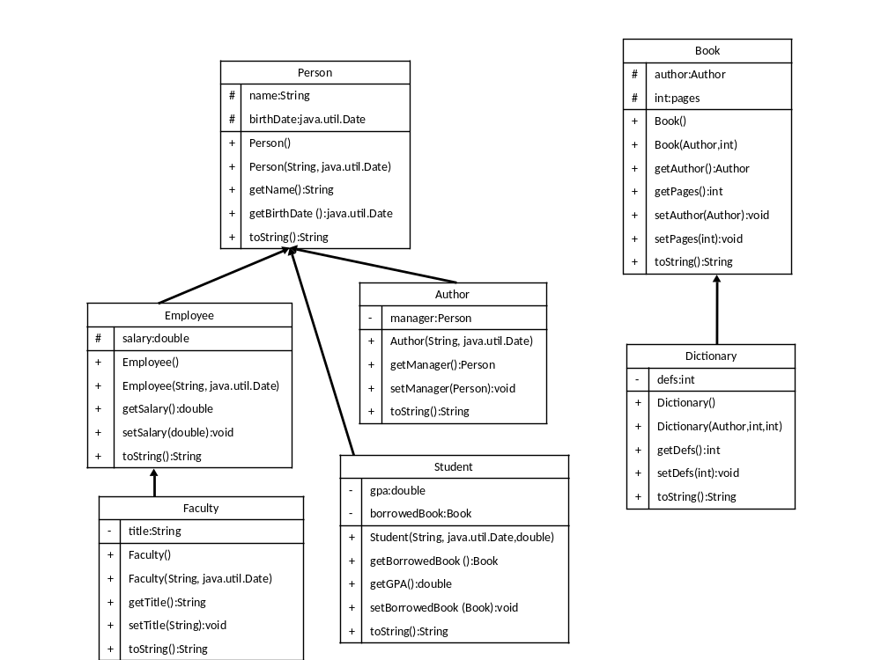

Here is the test class

import java.util.Date;

public class TestHw7 {

@SuppressWarnings("deprecation")
public static void main(String[] args) {

/* create an author */
Author joseph = new Author("Joseph Smile", new Date());

/* create an employee */
Employee yusuf = new Employee("Yusuf Gül", new Date());

/* create a manager */
Person mustafa = new Person("Mustafa Deva", new Date(1938, 11, 10));

/* set manager of joseph */
joseph.setManager(mustafa);

/* create a student with the same birth date of yusuf */
Student yahya = new Student("Yahya Doğru", yusuf.getBirthDate(), 3.87);

/* create a dictionary */
Dictionary whiteHome = new Dictionary(joseph, 6666, 114);

/* create a faculty */
Faculty abraham = new Faculty("Abraham Jacob", new Date());
abraham.setTitle("Prof");

/* now display the objects */

System.out.println(whiteHome);
System.out.println("---------");
System.out.println(yahya + " " + yahya.getName());
System.out.println("---------");
System.out.println(joseph + " " + joseph.getName());
System.out.println("---------");
System.out.println(yusuf + " " + yusuf.getName());
System.out.println("---------");
System.out.println(mustafa);
System.out.println("---------");
System.out.println(abraham + abraham.getName());
System.out.println("---------");
/* update a few fields */
yusuf.setSalary(2750.500);
yahya.setBorrowedBook(whiteHome);

/* display changes */
System.out.println(yahya.getBorrowedBook());
System.out.println("---------");
System.out.println(yusuf + " " + yusuf.getName());
System.out.println("---------");

/* check subclass hierarchy */
System.out.println(joseph.getClass().getSuperclass());
System.out.println("---------");
if (yahya instanceof Person && whiteHome instanceof Book) {
System.out.println("good deal :)");
}
System.out.println("---------");

if (abraham instanceof Person && abraham instanceof Employee
&& abraham instanceof Faculty) {
System.out.println("Abraham is a grandchild.");
}
}

}

Here is the sample output

Dictionary [defs=114]
---------
Student [gpa=3.87, borrowedBook=null] Yahya Doğru
---------
Author [manager=Person [name=Mustafa Deva, birthDate=Mon Dec 10 00:00:00 EET 3838]] Joseph Smile
---------
Employee [salary=0.0] Yusuf Gül
---------
Person [name=Mustafa Deva, birthDate=Mon Dec 10 00:00:00 EET 3838]
---------
Faculty [title=Prof]Abraham Jacob
---------
Dictionary [defs=114]
---------
Employee [salary=2750.5] Yusuf Gül
---------
class Person
---------
good deal :)
---------
Abraham is a grandchild.

